DFA – TOC_LAB
- Design DFA using simulator to accept the input string “a” ,”ac”,and ”bac”.
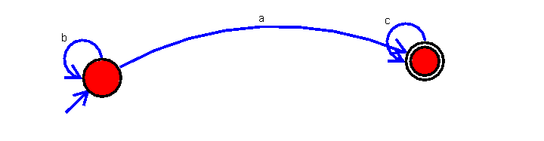

- Design DFA using simulator to accept even number of a’s.
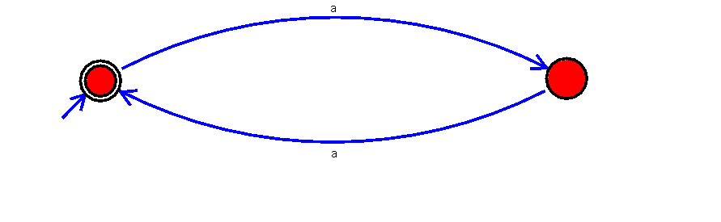

- Design DFA using simulator to accept odd number of a’s
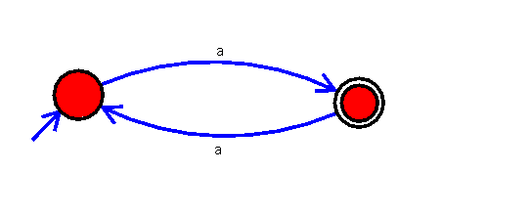

- Design DFA using simulator to accept the string the end with ab over set {a,b)
W= aaabab

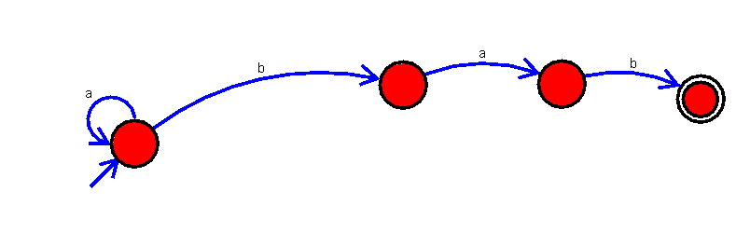

- Design DFA using simulator to accept the string having ‘ab’ as substring over the set {a,b}
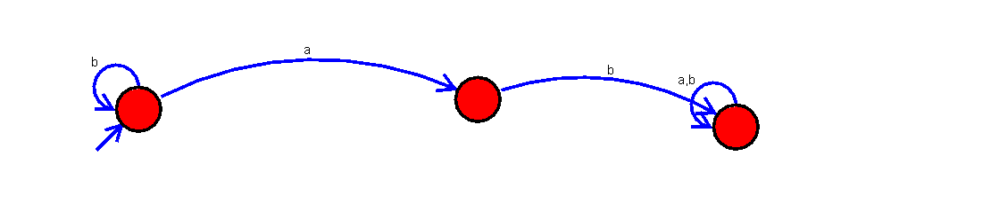

- Design DFA using simulator to accept the string start with a or b over the set {a,b}
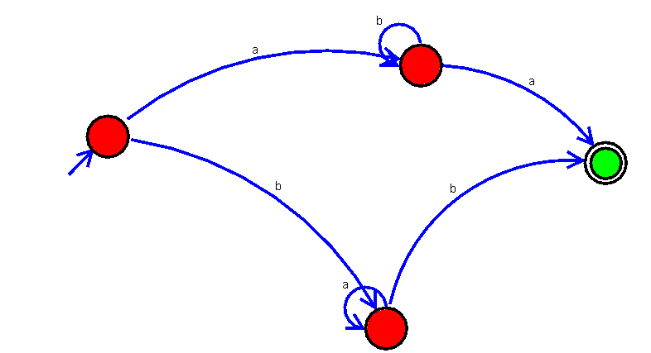

- Design DFA using simulator to accept the string the end with ab over set {a,b)
W= abbaabab

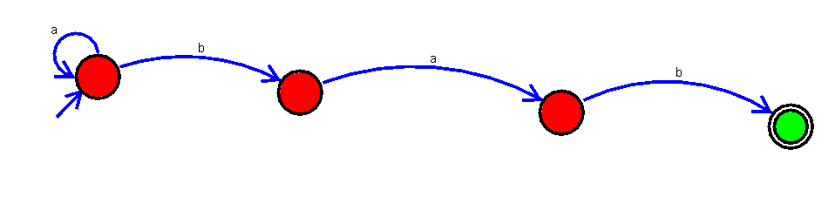

- Design DFA using simulator to accept the input string “bc” ,”c”,and ”bcaaa”.

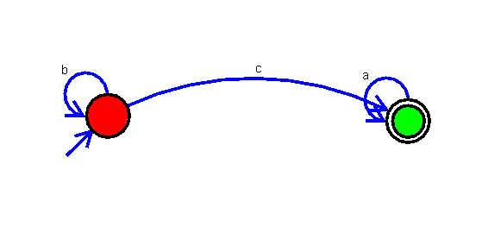

- Design NFA to accept any number of a’s where input={a,b}.

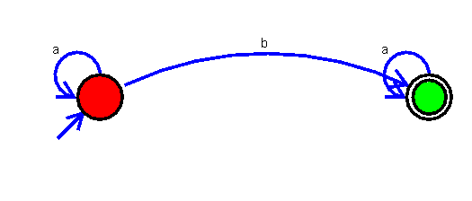

- Design DFA using simulator to accept the string having ‘abc’ as substring over the set {a,b,c}

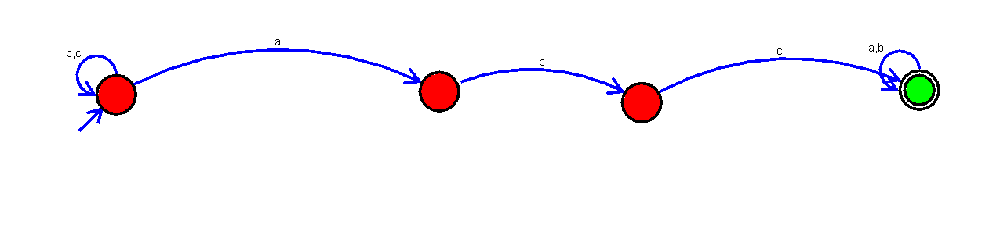

- Design DFA using simulator to accept even number of c’s over the set {a,b,c}

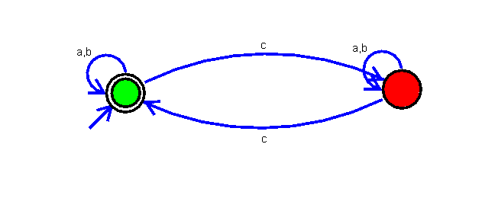

- Design DFA using simulator to accept strings in which a’s always appear tripled over input {a,b}

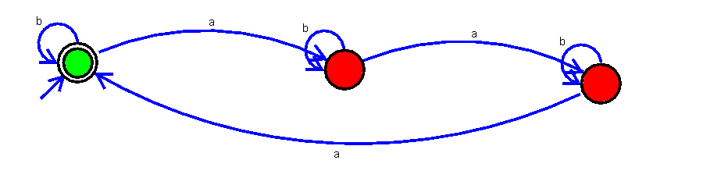

- Design NFA using simulator to accept the string the start with a and end with b over set {a,b} and check W= abaab is accepted or not.

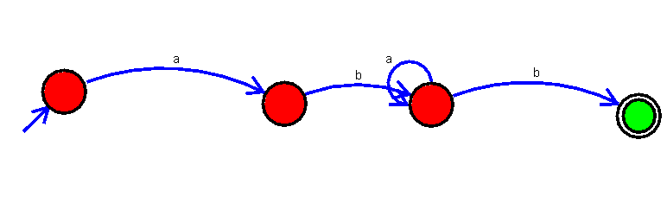

- Design NFA using simulator to accept the string that start and end with different symbols over the input {a,b}.

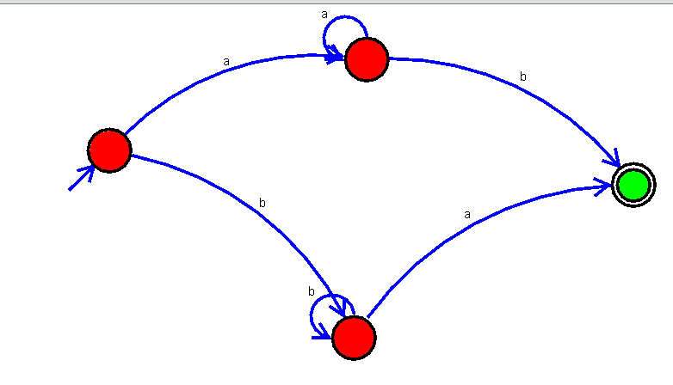

- Design NFA using simulator to accept the input string “bbc” ,”c”,and ”bcaaa”.

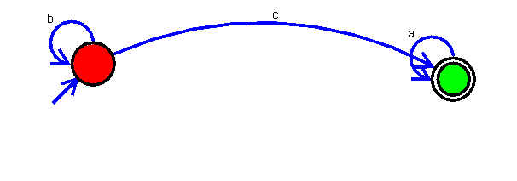

- Design DFA using simulator to accept the string the end with abc over set {a,b,c)
W= abbaababc

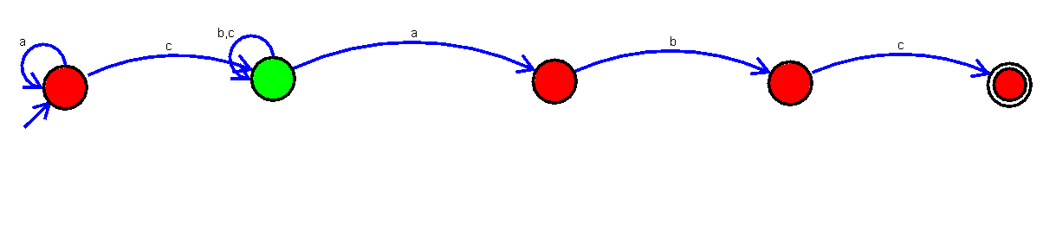

- Design NFA to accept any number of b’s where input={a,b}.

